**CarAvang: Post and Rent Cars**

**Mobile Application**

**System**

A Research/Capstone Project

Presented to the Faculty of the

College of Computer Studies and Information Technology,

Southern Leyte State University

In Partial Fulfillment of the Requirements

for the degree Bachelor of Science in Information Technology

By

Jess Christian Retulla

Jobe Paran

Kenn Francis Villas

Fred Matthew Espiel

Mr. Rhoderick Malangsa

Adviser

May, 2022

Republic of the Philippines

**SOUTHERN LEYTE STATE UNIVERSITY**

Sogod, Southern Leyte

Website: www.slsuonline.edu.ph

Email: [slsumaincampus@gmail.com](mailto:slsumaincampus@gmail.com)

op@slsuonline.edu.ph

Telefax No. (053) 382-3294

# College of Computer Studies and Information Technology

**APPROVAL SHEET**

The Capstone Project Study entitled CarAvang: Post and Rent Cars Mobile Application System prepared and submitted by __Team Hilongos_2.0_has been examined and is recommended for approval and acceptance.

|  |  |  |
| --- | --- | --- |
| RECOMMENDED:    _Mr. Rhoderick Malangsa_  Adviser | _______________________________  ITSO Manager | _____________________________  Research Facilitator |

=====================================================================

APPROVED by the Committee on Oral Examination with a grade of PASSED on___________________________.

__________ Mr. Alex C. Bacalla_________

Chairman

______ Ms. Jannie Fleur Orano _______ _____________Mr. Jimson Olayvar _______

Member Member

=====================================================================

ACCEPTED and APPROVED in partial fulfillment of the requirements in Bachelor of Science in Information Technology.

Mr. Alex C. Bacalla Dean, CCSIT

Date: _______________

**Dedication**

This project is dedicated to our families and friends for their unending support and encouragement throughout the making of this project. Without them, we would not have been able to accomplish this now. We are so blessed to have them in our lives. Thank you very much. We love you all.

**Acknowledgment**

First of all, we would like to thank our Almighty Father for guiding us always and providing us the knowledge to make all of this possible.

We also sincerely thank Mr. Rhoderick Malangsa, for being our adviser in making this proposal. We thank him for all the suggestions and the guidance he provided us in this. We also thank him for his support for our group in this proposal.

We also thank our dear panelists for sparing us some of their time in our oral defense.

This assignment cannot be completed without the effort and cooperation from our group members, and we are grateful because we managed to make it to the oral defense.

Last but not least, we would like to express our gratitude to our families and friends for the unending support they have given us.

**Abstract**

Nowadays, driving a private vehicle is one of the most effective way to help prevent the spread of the coronavirus. When using public transportations, there is a very high risk of making contact with someone who carries the virus. And since not all people have the financial capability of buying their own car, this is where the car rental business come in. They provide a car for rent with a rate for how many days you want to rent a car. This can help people who just want to use a car for a specific purpose, without the need of buying a brand-new car in full. Since our technology has greatly advanced through the years, online transactions have become so widely popular in todays’ generations. And renting a car is no exception. With the proposed application of the researchers, people can now rent cars faster and easier with the use of internet connection and a mobile phone. The main objective of the application is to provide a safer alternative to renting a car. Instead of personally going in person to a car rental business, you can just do all of it at your home, via online.

**Table of Contents**

Chapter I – Introduction 1

* Project Context 2
* Purpose and Description of the Project 2
* Objectives of the Project 2
* Scope and Limitations of the Project 3

Chapter II – Review of Related Literature 4

* Related Literature/Theoretical Background 4
* Related Studies 5

Chapter III – Technical Background 7

* Technicality of the Project 7
* Details of the technologies to be used 7
* How the project will work 8
* Architectural Layout 9

Chapter IV – Methodology 10

Environment 10

Locale 10

Population of the Study 10

Organizational Chart/Profile 11

Requirements Specification

Operational Feasibility 11

Fishbone Diagram 12

Functional Decomposition Diagram 12

Technical Feasibility 13

Compatibility Checking 12

Relevance of the Technologies 13

Schedule Feasibility 14

Gantt Chart 14

Economic Feasibility 14

Cost and Benefit Analysis 15

Cost Recovery Scheme 15

Requirements Modeling

Input 16

Process 16

Output 16

Performance 16

Control 16

Data and Process Modelling 17

Risks Assessment Analysis 21

Design

Output and User Interface Design 22

Data Design 23

System Architecture 25

Development

Software Specification 31

Hardware Specification 39

Program Specification 31

Programming Environment 32

Test Plan 32

Testing

Unit Testing 38

Integration Testing 38

System Testing 39

Conclusion 39 Recommendations 39 Implementation Plan 40

Project Implementation Checklist 40

Implementation Contingency 40 Infrastructure/Deployment 40

Bibliography 41

Appendices

Appendix A – Relevant Source Code 43

Appendix B – Evaluation Form 45

Appendix C – Sample / Output / Reports 46

Appendix D – Users Guide 48

Appendix E – Other Relevant Documents 49

Appendix F – Working Tile Form 60

Appendix G – Grammarian’s Certification 61

Appendix H – Curriculum Vitae 62

**Chapter 1 – Introduction**

With the pandemic going on, people have been avoiding as much as possible riding on a public transportation, but buying their own car is too expensive for some people and that’s why people turn to car rentals. We are aiming to make a reliable, fast and easy to use service that can be accessed using a mobile phone. The system will consist of significant features in order to satisfy the customers’ need. The system will then inform the car rental company of the rental request.

This Car Rental System will greatly help speed up the process of which people can rent cars from rentals. It is also a solution amidst this pandemic to help people avoid crowded places as much as possible because ordering online or transactions online have become the normal nowadays.

**Project Context**

Renting a car has been getting very popular through the years. Before, people who drive cars are only those people who can afford to buy one. But now, there are companies or businesses who offer car rentals for people who wants to use a car but cannot afford to buy their own car. Specially in these times of pandemic, owning a vehicle to minimize contact with other people through public transport is a must.

That is where the proposed system hopes to make car rentals much easier, much faster and much safer. If anybody wants to rent a car, there is a need to travel to where there is a service for car rentals. Appointment also is needed to reserve a car through rental establishments. This proposed system eliminates the physical travel from point A to point B just to reserve the car for rental.

A research on online car rental system can be a big opportunity for people to make transactions fast and safe. It is also an opportunity for businesses who offer car rental transactions as alternative to renting and that is through online. The development of this system for this pandemic can mitigate the spread of the virus in a public/crowded transportation.

**Purpose and Description of the Project**

With the popularization of renting cars and the growing technology, online car rental system has become a very useful project. The purpose of this is to be able to rent cars online without much hassle and much faster compared to going to the shop to rent a car.

The project will be accessible through online with the use of internet connection and a personal computer or laptop or mobile phone. The user will make an account and then he/she can then choose a car that is available for renting. This can be done all through the use of this car rental system. This greatly benefits both the user and the rental business.

In our area, we have noticed that car rentals have been getting popular through posts we see on social media. But the problem is, there is not a proper way to rent cars yet other than meeting up directly with the owner of the car rental and it is really inconvenient having to go there in person and finding out that there are no available cars for rent because all units are reserved already. This proposed system is planned to be implemented in our local area which is Hilongos and nearby towns such as Inopacan, Hindang, Bato and Matalom.

The expected number of car rental establishments are around 5 or more. There are also individual people who will post their own car for rentals. The expected number of people who rent cars are around 50 or more.

**Objectives**

General Objective:

The main objective of this system is to speed up the process of which people rent a car by doing it online. By using this system, the user can choose a car of liking that is available for rent with the use of the gadget and an internet connection. The user can choose on certain car specifications or performance to appropriately satisfy the customer’s needs. Creating a car rental system that is reliable, user-friendly and with a great security to protect customer privacy and to avoid scams. This proposed system also aims to help car rental companies by providing staff with information about customers and order. This also helps private owners to help rent their own cars safely.

Specific Objectives:

This study has the following objectives:

* Create a model design of a web-based application for online reservation of car from a car renting business.
* Develop a dashboard.
* Develop a notification feature.
* Create reports.

**Scope and Limitations of the Project**

The system will have a login/register feature. A dashboard is also included in the proposed system. The system will also send a notification when a new user has sent a rental request. There will be a tracking feature included in the system through the use of GPS so that car owners won’t worry about the customers running away with their cars. The cars for rent will be having standards on sanitization whether it can be rented, to avoid spread of the pandemic virus. And lastly, the system will have a Warning System to alert the owner and the person who rented the car that there is a breach in the agreement of both sides.

The Features:

- 50% percent downpayment

- Verification of user (hardcopy, softcopy of valid I.D)

- Budget Vehicle (You can search for a car of your choice including color, size, type, capacity)

- Calendar Booking

- Individual Rating

- Individual car owners can post their own vehicle for rent

- Notifies use when the car is ready to rent

- GPS tracking

-Warning System

The limitation of the study is that the system will not be able to allow users to change their provided information once their account has been made. The system also only focuses on selected areas which are Inopacan, Hindang, Hilongos, Bato and Matalom. Moreover, there are a limited number of cars available for rent so if the bookings are full, people will have to wait until an available car is ready. But despite the limitations, the system will help a lot of people specially people who don’t know where to rent a car in the area.

**Chapter 2 – Review of Related Literature**

[1] The motivation behind this research is the growing popularity of web-based systems and the need to explore the Short Message Service (SMS) technology that industries could tap into to enhance their services to their customers. The main purpose is to reduce the cost and time consumed, which is beneficial to the car rental agencies and customers. The system automatically sends an alert SMS to the customers about the availability of the car reserved.

*(Computing Research & Innovation (CRINN) Vol 2, October 2017)*

[2] Avis Indonesia has car rental system that is involving the customer’s inquiries. They will fill out forms to rent a car. The form will be submitted to the office. After the verification process is completed, car and the driver’s information will be delivered through the system, along with rental history records. Based on the analysis, the information system could increase the time efficiency on average up to two days for delivering the car to customers and a paper cost savings.

*(Development of Car Rental Management Information Systems (Case Study: Avis Indonesia))*

[3] The Car Rental System is being developed for customers so that they can book their cars from any part of the world. This application takes information from the customers through filling their details. A customer being registered in the website has the facility to book a Car which he requires. The proposed system is completely integrated online systems. It automates manual procedure in an effective and efficient way. This automated system facilitates customer and provides to fill up the details according to their requirements. It includes type of car they are trying to hire and location. The purpose of this system is to develop a web site for the people who can book their Car along with requirements from any part of the world. Car rental system provide Car to User in their location on short time.

*(****ONLINE CAR RENTAL SYSTEM*** *- N SINGH, VG PANDEY - 2021 - 103.47.12.35)*

**Related Systems**

[4] A car rental is a process to allow use car temporarily for a period with a fee renting, with technology customers need to reduce the time and effort in obtaining their needs, and we find that some customers who stay for temporary periods in places other than where they live have a desire to get a car for rent. Through this research will develop an electronic webbased system to provide a service Car rental for customers as well as the possibility of managing car rental agencies for the owner. This system will present an excellent tools tool for fast and accurate development of car rental service. Agile methodology and WebML methodology relied upon to carry out the search. The electronic web-based system application will allow improvement and quality of services provided to clients who have the desire to get a car for rent, and the car rental agencies that offer car rental services, and also the electronic system provides monitoring of cars that will be rented through the GPS service, which facilitates the process of controlling rental cars, Also some electronic system components will be added and reused.

*(CAR RENTAL AND TRACKING WEB-BASED SYSTEM USING GPS)*

[5] Car rental agencies primarily serve people who require temporary vehicles. However, many car rental damage scam cases involving car renter fail to present any evidence and being unfairly charged, for the damage that did not happen during rental. Concerning the current car rental systems that only allow customers to inspect the physical condition of the car, the objective of this project is to develop a mobile application for car rental system, FoRent, that implements the car diagnostic features. Through this system, the car owner and car renter will be able to record the physical condition and retrieve forensic data of the car using ELM327 device, before signing the rental agreement. In order to reduce security risk, this project introduces a security protocol to provide the integrity and availability of the data in FoRent. Enhancing the existing paper-and-pen car rental system, FoRent is remarkable as it introduces these special features that meet the requirement of the car rental company and customers.

*(FoRent: vehicle forensics for car rental system)*

[6] A mobile car rental system that is secured and enabled users to reserve the vehicle they wanted. The proposed mobile car rental system has been replaced by the traditional way of renting vehicles. General functions such as adding, editing and removing information will be added to the mobile app. Other features such as login, direct call and send email, direct location, check vehicle availability, check vehicle reservation, and so on will be added to the mobile app. The app also allowed users to view the rental car available, make payment for the rental car using a credit card that ensures that users do not have to be physically present at the rental company just to see what rental car they want to rent. Instead, users could browse the car rental list through the Mobile Car Rental System, no matter how many times, and then decide which car to choose and proceed for payment process.

*(A Prototype of a Mobile Car Rental System - Chit Su Mon1, Tan Khee Tee1 and Amir 'Aatieff Amir Hussin1)*

[7] Smart matching for car rental mainly supports the process of car matching in a search function to give the most satisfaction result for customers and avoid the rejection of unavailable car for rent by providing the alternative available cars that close to the customer's requirement. For the search function, we analyze the problems found in general car rental system and identify the importance characteristic of the rental car. Then, we design the attributes with weighting method for matching customer's requirement for car rental along with the available cars for avoiding the rejection to the customer as much as possible. In the experiment, we develop the smart matching system to improve and solve the problems of existing car rental system such as Avis and Hertz in comparison.

*(Smart Matching for Car Rental)*

**Chapter 3 – Technicality of the Project**

The researchers had gathered related studies about the project and brainstormed the technologies to be used. The hardware to be used in this project would be a personal laptop. Software can be picked once we carry out the system as it is still ongoing.

The researchers have access to a personal laptop to be used in the making of this online car rental system. The researchers will be working together to solve challenges and help each other to achieve the desired goal. Online Car Rental System allows users to be able to rent cars online and it is an IT related project.

**Details of the Technologies to be used**

The researchers will be using a personal laptop in making this system. The software that we will be planning to use will be using the Java language. Because it is highly recommended when creating some projects such as this Online Car Rental Mobile Application. We chose this because it is a highly secured programming language for applications.

**Hardware**

• PC or laptop – use to make the proposed system.

• Mobile Phones – used to open the mobile application and receives notifications from the system.



**Software**

• MySQL – a database that stores information’s that is useful to the program

• Microsoft PowerPoint – a software that will used to present our project.

• Google Chrome – searching information that can help our project.

• JAVASCRIPT – use to develop the application.

• Microsoft Word – Compiles the details of the capstone project.

Software to be used: NetBeans or Android Studio

**How the Project will work**

The users would first register an account in the Online Car Rental System. The user would need a mobile phone and he/she must be connected to the internet. They would have to enter their information like their name and address. Then the user would need to log in to their registered account. Then they will pick an available car for renting. After choosing, they would then need to confirm their transaction. After confirming, the system would then inform the car rental service about the transaction so they can then reserve the car for the user.

**Architectural Layout**





USER

Wait for Reservation Request

**Post Vehicle for Rent**

Post Vehicle for Rent

Payment

Reservation Confirmation

**Cancel reservation**

**View available cars**

**Rent Car**

Rent Car

Database

Internet

CarAvang – Post and Rent Cars

Create Account/Log In



Warning System

GPS Tracking

**Payment Option**

**GPS**

**Tracking**

**Warning System**





USER & Company

**Chapter IV – Methodology**

Environment

Locale

This chapter explains the method and procedures being followed in the research project. This chapter reviews the research approach used to carry out the study, the research respondents, and the research methods used for conducting the study. It also includes an overview of how to treat research data gathered by the researchers.

**CarAvang: Post and Rent Cars Mobile Application** is an application wherein clients can rent a car by using a mobile application. The system or application can help catering administration manage their filter, monitor, and store and secure of all the reservations records. The system will help the administration in making their work easy and fast such as updating, adding new set of cars, and printing of records since all the files will be stored in the database. It is more secure in an automated online system and it is more reliable in processing reports and records of the reservation than using manual based. Only the authorized personnel can access the system with the use of its username and password for the security purposes.

Population of the study

This study is focusing the municipalities of Inopacan, Hindang, Hilongos, Bato and Matalom wherein the proponents witnessed that commuters were hesitant to go in public transportation places because of the multiple cases of Covid. Moreover, we have come up this idea to create and develop a system that is useful for the commuter’s satisfaction, in terms of renting a car. The commuters will no longer getting hustle for the public transportation because of the mobile application for car rental system which commuters will just used the mobile application for renting. Because in these towns has the deficiencies of renting a car. So, we provide a system that can help individuals and car owners in this time of crisis and to minimize the effort of the commuters.

**Organizational Chart/Profile**

Project Manager:

Retulla, Jess Christian

System Analyst

Espiel, Fred Matthew

Technical Writer

Villas, Kenn Francis B.

Programmer, Tester

Paran, Jobe

**Requirements Specifications**

**Operational Feasibility**

*Fishbone Diagram*

The diagram below is the project’s Fishbone diagram, it demonstrates the elements that cause the fear of using public transportation by the people of our locality. Those stated elements are what is causing the issue the study will address. It shows in the diagram that the factors that are causing the issue are mainly the pandemic brought about by the Covid-19 virus and the expensive prices of vehicles that are not affordable to the masses.

They have led to the popularization of car rentals in our local municipality.

CAUSES EFFECT

Pandemic

Fear of getting the virus.

Car Rental becoming popular

Want to have their own vehicle for use.

Lifestyle

Figure 3. Fishbone Diagram

*Functional and Decomposition Diagram*

The diagram below is the Functional Decomposition Diagram of the project. It shows the functionalities and the capabilities of the system. The user can search for and rent a specific car. They can also upload their own vehicle and put them up for rent in the system. The application has a login system along with a registration system for new users. The application is quite easy to use and it has several stages.

CarAvang: Post and Rent Cars Mobile Application

System

Post

Rent

Car Category

Log in/Sign Up

Car Information

Choose Category

Choose Car

Post Car

Book Car

Rental Summary

Figure 4. Functional Decomposition Diagram

***Technical Feasibility***

*Compatibility Checking (Hardware/Software)*

The CarAvang application can be usable in devices with the Android operating system with the minimum API of 21. The application will need the device to be connected to the internet as well.

*Relevance of the Technologies*

The technologies that are used in making this application successful are what made this application work. We tested the application in different various devices with the help of emulators and it has shown to be working. The project should be able to function and be accessible to most devices with relevance to android technologies.

***Schedule Feasibility***

*Gantt Chart*

The dates on which the researchers completed their assignment are listed in the chart below. It shows what happened and when it happened. Furthermore, it shows the dates by which each task must be completed.

Manuscript Document May 9, 2022

Conceptual Design Plan October 21, 2021

Project Design November 25, 2021

Project Development January 10, 2022

Project Testing April 18, 2022

Project Implementation May 3, 2022

Finalization May 19, 2022

***Economic Feasibility***

*Cost and Benefit Analysis*

The table below is the Cost and Benefit Analysis of the project these are the generalize expenses of the proponents in making the project. It shows that amongst the expenses the Internet expenses has accumulated more over the other expenses and is followed Transportation and Miscellaneous which garnered 500.00 pesos for each. And lastly, in finalizing the project, the proponents have spent 400.00 pesos for Paper & Photocopy Expenses.

Table 1. Cost and Benefit Analysis

|  |  |
| --- | --- |
| Expenses | Amount |
| Internet Expenses | 2,100.00 |
| Paper & Photocopy Expenses | 400.00 |
| Transportation | 500.00 |
| Miscellaneous | 500.00 |
| Total | 4,500.00 |

*Cost and Recovery Scheme*

The table below is the Cost and Recovery Scheme of the project. This reflects the division of expenses for each month starting January and ends in May. This shows that the overall expenses still the same from January to May. It shows that amongst the expenses the Internet expenses has accumulated more over the other expenses.

Table 2. Cost and Recovery Scheme

|  |  |  |  |  |  |
| --- | --- | --- | --- | --- | --- |
| Expenses | Jan | Feb | March | April | May |
| Internet Expenses | 400.00 | 400.00 | 400.00 | 400.00 | 500.00 |
| Paper & Photocopy Expenses | 0 | 0 | 0 | 0 | 700.00 |
| Transportation | 100.00 | 100.00 | 100.00 | 100.00 | 100.00 |
| Miscellaneous | 100.00 | 100.00 | 100.00 | 100.00 | 100.00 |
| Total | 600.00 | 600.00 | 600.00 | 600.00 | 1400.00 |

***Requirements Modeling***

The following figure shows the Requirements Modeling for the rent and post sides of the project. The rent side and the post side. It shows the inputs, process, control, generated outputs, and performances that the two sides are capable of implementing.

**PROCESS**

-Validate Login & Register

-Fetch Profile Info

-Rent Cars request

-Validate Payment

**PERFORMANCES**

-Multiple Registers

-Handles multiple requests

-Verify transaction

**OUTPUTS**

-Confirmation Messages

-Error Messages

-Rent car details

-List of Transaction Records

-Driver Information

**INPUTS**

-Login and Register

-Personal Information

-Rent Cars request

-Pickup Date

-Return Date

**CONTROLS**

-Validate Login & Register

-Inputs

-Password is Required

-Empty fields not allowed

Figure 5. Requirements Modelling for Renting

**PERFORMANCES**

-Multiple Registers

-Handles multiple requests

-Verify transaction

**OUTPUTS**

-Confirmation Messages

-Error Messages

-Rent car details

-List of Transaction Records

-Driver Information

**PROCESS**

-Validate Login & Register

-Fetch Profile Info

-Rent Cars request

-Validate Payment

**INPUTS**

-Login and Register

-Personal Information

-Post Cars request

**CONTROLS**

-Validate Login & Register

-Inputs

-Password is Required

-Empty fields not allowed

Figure6.Requirements Modelling for Renting

***Data Process Modeling***

*Context Diagram*

The diagram below shows the context diagram of the project it shows what are the essential reports, capabilities and/or features for both rent and post side of our project

.

Post

Rent

Rental Request Post Vehicles

Transaction

History

**Data**

Database

Figure 7. Context Diagram

*Data Flow Diagram*

The data flow for either side of the project is depicted in the figures below. Each figure demonstrates how data flows when users rent cars. Also, how data flows for the project's posting feature. Furthermore, the illustrations depict the general reports that each project component generates and shows.

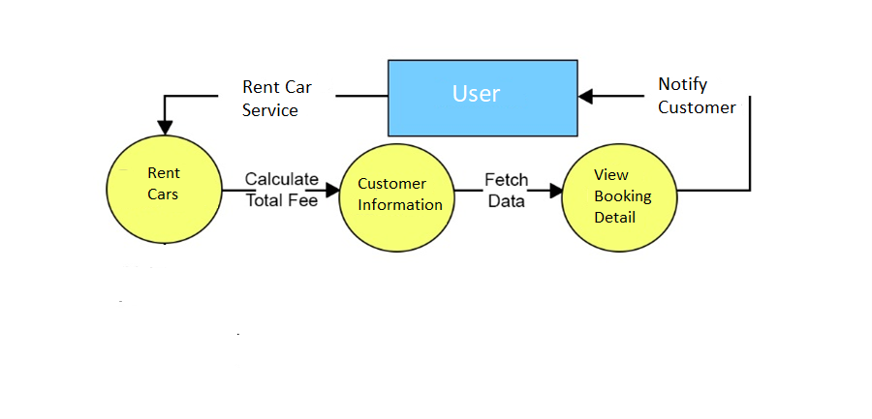

Figure 8. Data Flow Diagram for Commuters’ Side

Registration

Data

Login

Credentials

Driver

Validate

Input

Validate

Input

Register

Login

View or

Access

View

Customer

Information

Book

Vehicle

Figure 9. Data Flow Diagram for Drivers’ Side

*System Flow Chart*

The diagram below depicts the system's overall concept of how the system manages data and generates reports. The figure depicts the conditions that the system considers in each task and/or functionality for both the rent and post features of the system.

Figure 10. System Flow Chart

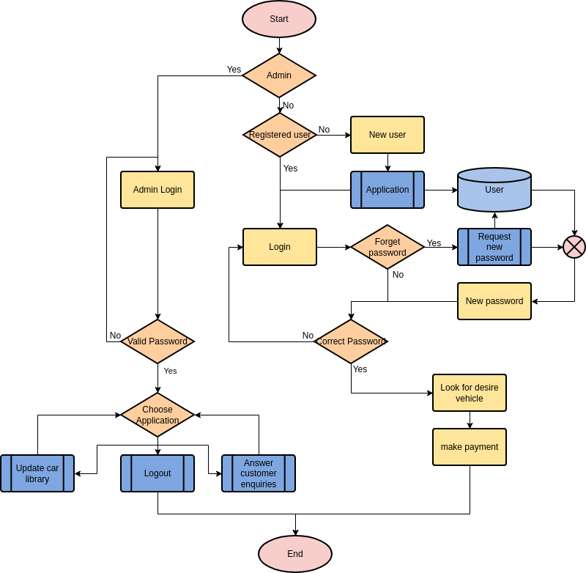

Figure 11. The Program Flow Chart of the system is shown below. This includes inputs and outputs and required reports.

*Risk Assessment/Analysis*

The project's Risk Assessment/Analysis is shown in the table below. The table also depicts the risk analysis that the researchers aim to use to ensure that the project runs well. The table also lists any potential roadblocks that the system may face during project execution and deployment. The table below will be used to identify the preventive actions to ensures the projects effectiveness.

Table 3. Risk Assessment/Analysis

|  |  |  |  |  |
| --- | --- | --- | --- | --- |
| Threat | Vulnerability | Impact | Risk | Control Recommendation |
| System Failure  Very High | Sudden internet connection loss  Very High | All services will be unable  High | Data will not be stored High | Choose a will trusted cloud service provider |
| Power interruption  Medium | Server firewall will be breached  Low | Data loss  High | Low  Data will not be stored | No actions. |
| Malicious Human Interference  Very High | Cloud server provider has Good Firewall  Low | Process will be compromised  High | Low  Services and Data breached | No actions. |
| Accidental Human Interference – Data Deletion Medium | Permissions and prompts are configured properly.  Medium | Services and functionalities will not be implemented properly. | Medium | Permissions and confirmations should be properly developed. |

**Design**

***Outputs and User-Interface Design***

*Forms*

The following images are used by the system to collect the necessary input from the users of the application for rental and posting. The forms also show what the application’s inputs and outputs are.

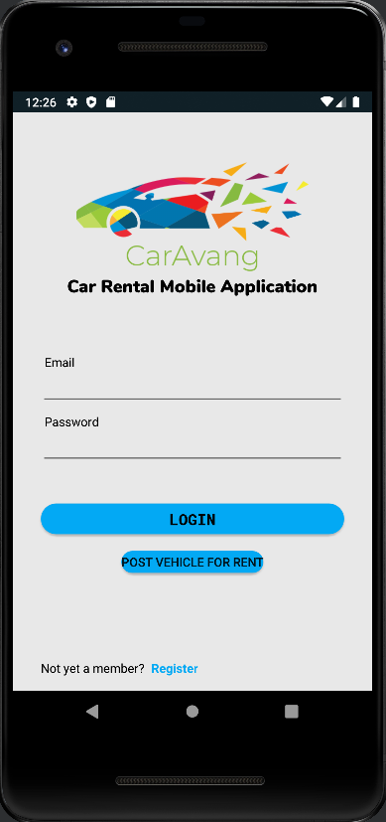

**Form 1. Login Page**

**Figure 2. Registration Page**

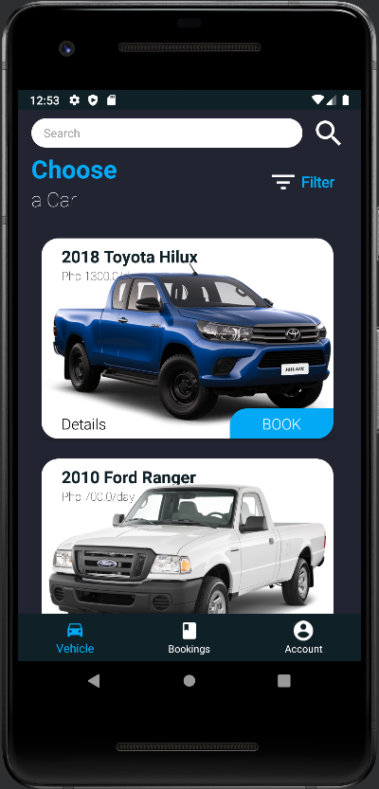

**Figure 3. Main Page**

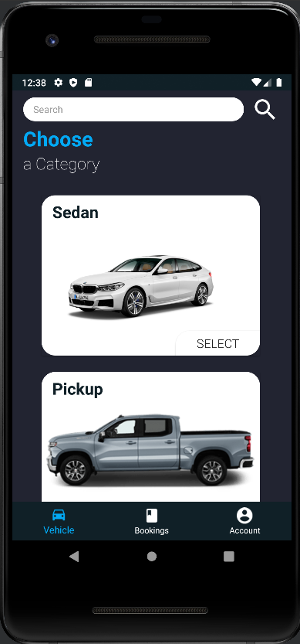

**Figure 4. Choose Car**

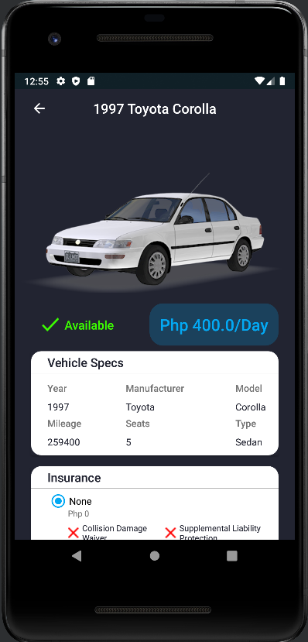

**Figure 5. Vehicle Specs**

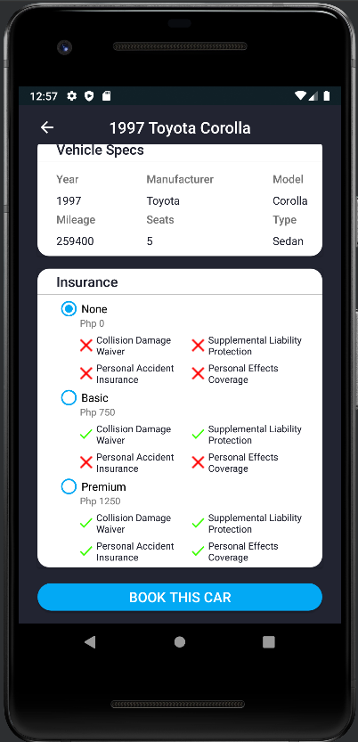

**Figure 6. Insurance**

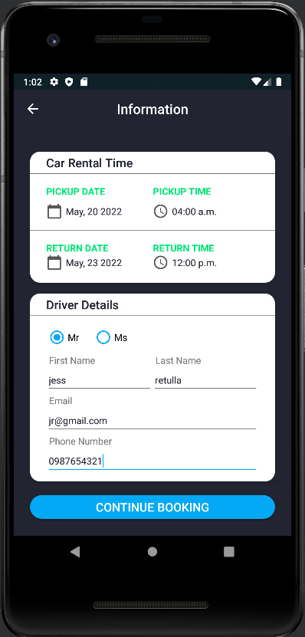

**Figure 7. Customer Information**

**APPENDIX C**

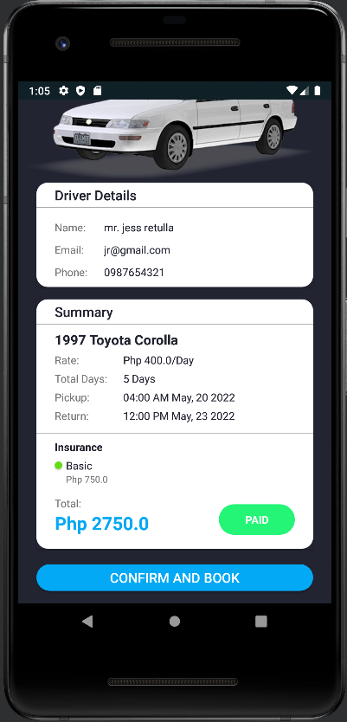

**Figure 8. Rental Paid**

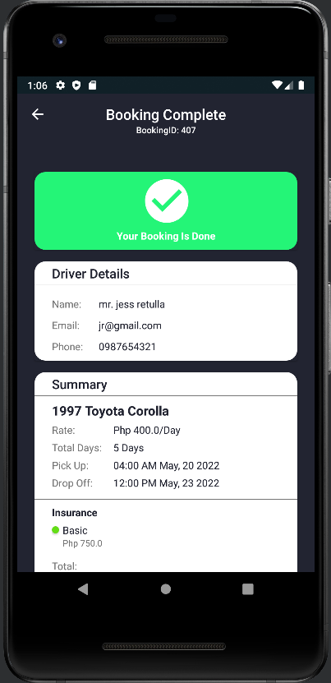**Figure 9. Booking Complete**

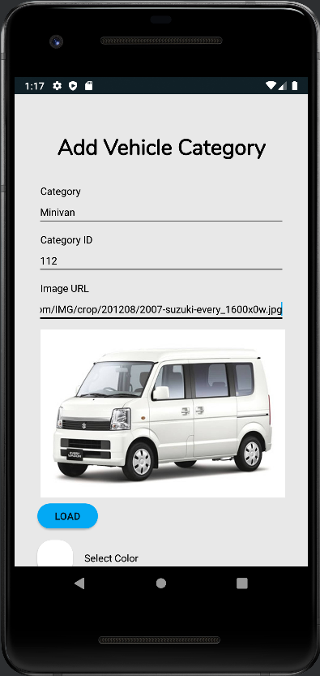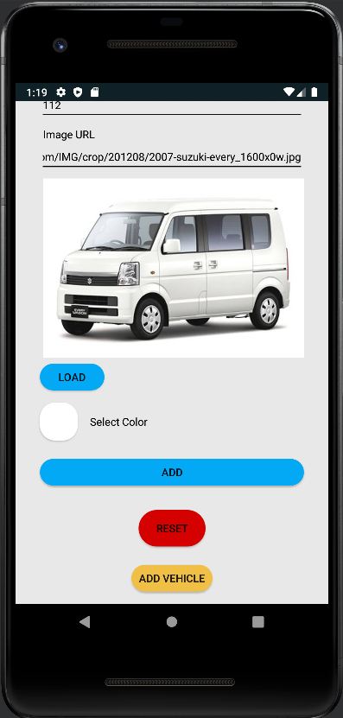

**Figure 10. Add Vehicle Category**

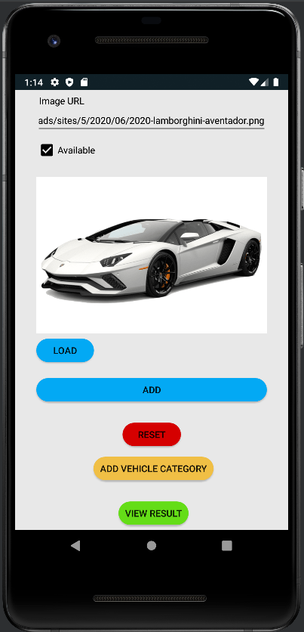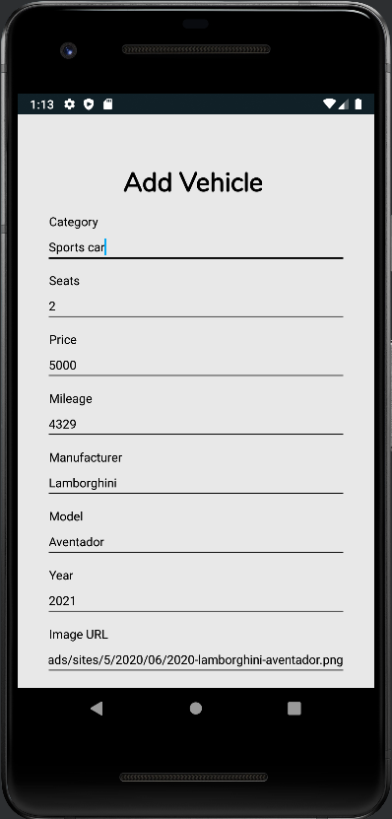

**Figure 11. Add Vehicle**

***Data Design***

*Entity Relationship Diagram*

The Entity Relation Diagram for the system is shown below. The graphic depicts the entities that the system employed to generate acceptable outputs and complete tasks that were required to accomplish the project's goal.

The entities reflect the many types of data that the system evaluates and analyzes to accomplish the project's goals.

|  |  |
| --- | --- |
| **USERS** | **BOOKINGS** |
| **PK Id**  **first_name**  **middle_name**  **last_name**  **email**  **account_name**  **username**  **password** | **PK id**  **FK pickup time**  **Return date**  **Total fee**  **Fee** |

Figure 13. Entity Relationship Diagram

*Data Dictionary*

The data dictionary for the project is shown in the table below. It represents the type of information that the system processes, validates, stores, and prints. The data dictionary is based on the Entity Relationship Diagram presented in the previous section.

Table 4. Data Dictionary for Users Table

|  |  |  |  |  |
| --- | --- | --- | --- | --- |
| Field name | Data type | Field size | Description | Example |
| Id | Big int | 10 | Unique primary key for each user | 5 |
| First name | String | 255 | First name for each of the user. | Jobe |
| Middle name | String | 255 | Middle name for each of the user | Jess |
| Last name | String | 255 | Last name for each of the user | Glenn |
| Email | String | 255 | E-mail for each of the user | [jparan@gmail.com](mailto:jparan@gmail.com) |
| Account Type | String | 255 | Account for each of the user | Customer |
| Password | String | 255 | Hashed password of each of the user | Jparan |
|  |  |  |  |  |

Table 5. Data Dictionary for Bookings Table

|  |  |  |  |  |
| --- | --- | --- | --- | --- |
| Field name | Data type | Field size | Description | Example |
| email | String | 10 | Unique primary key for each user | jp@gmail.com |
| Drivers License | Integer | 10 | Drivers license of the booking details | 6178236 |
| Phone number | Integer | 10 | Phone number of the user | 09732479827 |
| Date of birth | String | 10 | Date of the user’s birth | Jan 12 1999 |
| Password | String | 255 | Password of the user | jobe |
| Street | String | 255 | Home street of the user | Talisay |
| Total Fee | Double | 10 | Total Fee for each booked car | 120.00 |
| Status | String | 255 | Status for each of the booked detail | On the way |

***System Architecture***

*Network Model*

The project network model is depicted in the graphic below. It demonstrates how each step and/or process is linked for both the rental process and the posting process. This model was developed to depict the relationships between objects and processes on each project sides.

**Development**

***Software Specification***

The following are the software requirements for the system to be fully functional and accessible to both drivers and commuters.

* Operating system
  + Windows 7-11
  + Latest android versions

***Hardware Specification***

The following are the software requirements for the system to be fully functional and accessible to both drivers and commuters.

* 4GB Ram and Above
* At least Inter Core i5

***Program Specification***

The following are the required program specification for the system to be accessible and be fully functional for both the drivers and the Commuters.

* Programming Language Support
  + Java
  + Android Studio

***Programming Environment***

**Table 6. Project Programming Environment**

|  |  |
| --- | --- |
| Front End | Back End |
| * Android Studio * Javascript | * **DataBase** |

***Test Plan***

Table 7. Project Test Plan

|  |  |  |  |
| --- | --- | --- | --- |
| Test Case | Description | Test Step | Expected result |
| Functionality | Each functionality, features, capability of the system. | Inputs, reports and request can be done simultaneously for both sides | Reports should be accurate. Function w/o errors. |
| Response Time | The amount of time for the system to generate reports and validate inputs. | Output and report generation is fast for both sides. | Response is fast and input validation is efficient. |
| Security | Ensure login credential checking. | Should be able to login according to login credentials. | Entered data are secured. |
| Usability | Each side is accessible. | Public users can search and trace location. Authorized personnel can do task seamlessly. | Every function can be done with no errors. |

**Testing**

***Unit Testing***

The unit testing for each module used in the project is listed in the tables below. Every module in the project represents a single form, and each module is tested according to its type, function, and desired outcome**.**

Table 8. Unit Testing Result 1

|  |  |  |  |
| --- | --- | --- | --- |
| Login Form | | | |
| Field | **Event** | Failed | Success |
| Email Address | Text changed | Error message – “Please fill form accordingly”. | Initialize login and validate input. |
| Password | Text changed | Error message – “Please fill form accordingly”. | Initialize login and validate input. |
| Login button | Click event | Error message – “Please fill form accordingly”. | Initialize login and validate input. |
| Register button | Click event | No implemented action | Initialize register page. |
|  |  |  |  |

Table 9. Unit Testing Result 2

|  |  |  |  |
| --- | --- | --- | --- |
| Register Form | | | |
| Field | **Event** | Failed | Success |
| First name | Text changed | Error message – “Please fill form accordingly”. | Initialize register and validate input. |
| Middle name | Text changed | Error message – “Please fill form accordingly”. | Initialize register and validate input. |
| Last name | Text changed | Error message – “Please fill form accordingly”. | Initialize register and validate input. |
| Home Address | Text changed | Error message – “Please fill form accordingly”. | Initialize register and validate input. |
| Birth date | Date Select | Error message – “Please fill form accordingly”. | Initialize register and validate input. |
| Age | Text changed | Error message – “Please fill form accordingly”. | Initialize register and validate input. |
| Username | Text changed | Error message – “Please fill form accordingly”. | Initialize register and validate input. |
| Email address | Text changed | Error message – “Please fill form accordingly”. | Initialize register and validate input. |
| Account Type | Item Select | Error message – “Please fill form accordingly”. | Initialize register and validate input. |
| Password | Text changed | Error message – “Please fill form accordingly”. | Initialize register and validate input. |
| Confirm Password | Text change | Error message – “Password input doesn’t match”. | Initialize register and validate input. |
| Register button | Click event | No implemented action | Initialize register and validate input. |
| Login Button | Click event | No implemented action | Initialize login page. |

Table 10. Unit Testing Result 3

|  |  |  |  |
| --- | --- | --- | --- |
| My Profile Form | | | |
| Field | **Event** | Failed | Success |
| First name | Text changed | Error message – “Please fill form accordingly”. | Initialize register and validate input. |
| Middle name | Text changed | Error message – “Please fill form accordingly”. | Initialize register and validate input. |
| Last name | Text changed | Error message – “Please fill form accordingly”. | Initialize register and validate input. |
| Home Address | Text changed | Error message – “Please fill form accordingly”. | Initialize register and validate input. |
| Birth date | Date Select | Error message – “Please fill form accordingly”. | Initialize register and validate input. |
| Age | Text changed | Error message – “Please fill form accordingly”. | Initialize register and validate input. |
| Username | Text changed | Error message – “Please fill form accordingly”. | Initialize register and validate input. |
| Email address | Text changed | Error message – “Please fill form accordingly”. | Initialize register and validate input. |
| Password | Text changed | Error message – “Please fill form accordingly”. | Initialize register and validate input. |
| Confirm Changes | Button Click | Button click | Initialize update and validate input. |
|  |  |  |  |

Table 11. Unit Testing Result 4

|  |  |  |  |
| --- | --- | --- | --- |
| Book for Ride Form | | | |
| Field | **Event** | Failed | Success |
| Pickup Date | Item Select | Error message – “Please fill form accordingly”. | Initialize Map. |
| Return Date | Item Select | Error message – “Please fill form accordingly”. | Initialize Map and enable routing. |
| Passenger Count | Text changed | Error message – “Please fill form accordingly”. | Initialize Passenger Count |
| Confirm Button | Button Click | No Implemented Action. | Send Book for Ride Details. |
|  |  |  |  |
|  |  |  |  |

Table 12. Unit Testing Result 5

|  |  |  |  |
| --- | --- | --- | --- |
| Request Form | | | |
| Field | **Event** | Failed | Success |
| From | Not implemented Action. | Not implemented Action. | Display requested starting location. |
| To | Not implemented Action. | Not implemented Action. | Display requested destination. |
| Passenger(s) | Not implemented Action. | Not implemented Action. | Display requested # of passengers. |
| Date Requested | Not implemented Action. | Not implemented Action. | Display date requested. |
| Driver Full name | Not implemented Action. | Not implemented Action. | Display drivers full name. |
| Driver’s plate # | Not implemented Action. | Not implemented Action. | Display driver’s plate #. |
| Status | Not implemented Action. | Not implemented Action. | Display request status |
| Cancel button | Button click | Not implemented Action. | Cancel request. |

Table 13. Unit Testing Result 6

|  |  |  |  |
| --- | --- | --- | --- |
| Timeline Form | | | |
| Field | **Event** | Failed | Success |
| From | Not implemented Action. | Not implemented Action. | Display requested starting location. |
| To | Not implemented Action. | Not implemented Action. | Display requested destination. |
| Date Requested | Not implemented Action. | Not implemented Action. | Display date requested. |
| Customer name | Not implemented Action. | Not implemented Action. | Display drivers full name. |
| Status | Not implemented Action. | Not implemented Action. | Display request status |
|  |  |  |  |
|  |  |  |  |

***Integration Testing***

*Compatibility Testing*

Because of its nature, the project was tested on different google android versions to check if the application could work on different environments.

*Performance Testing*

The project testing phase then moved on to testing the system's performance. The application demonstrates that the performance is totally dependent on its internet access. Furthermore, the Google APIs that the system uses are heavily reliant on internet access. The internet connection must be monitored regardless of which browser is used to access the system. With this exception, the project proved to be efficient and effective.

*Stress Testing*

To test the system's ability to work beyond its intended use. As a result, the system's ability to handle stress from many data requests and validation was put to the test while using the above-mentioned internet browsers at the same time.

*Load Testing*

The system's ability to handle large amounts of data was tested by storing large amounts of commuters’ data and registering accounts from the project's rental side by adding more cars to the database. It was discovered that when the amount of data saved in the project's database reaches a particular threshold, data retrieval from the both sides of the project takes longer response time..

***System Testing***

This research stated that the system has gone through routine testing steps. The system was put through a total of six testing phases, each of which assessed the system's ability to work and run when various operational obstacles were encountered. Regardless, the system performed well in all the main areas that were examined throughout development.

**Conclusion**

Based on the findings and data gathered from testing the system on various operational hindrances, the proponent of the study concludes that:

1. The application is very useful in finding available vehicles to rent and to easily post your car for rental. It can be the solution to have a stress-free car booking.

2. The application is a good way to save your time from looking for vehicles.

**Recommendation**

The application is effective and is advantageous in providing a car rental service for the people of Hilongos, Hindang, Inopacan and Matalom as there are a lot of people who rely on these kinds of services.

1. The application must have rate service feature to provide interactivity.
2. Real-time user location feature, to automate a user’s starting location information. GPS can be used to for the location feature, to determine the location of the one who rented the vehicle.

**Implementation Planning**

***Project Implementation Checklist***

The proponents analyzed facts that would pave more ways to make the project execution as effective and accurate as possible during the implementation phase. The table below contains a list of items to consider completing the project and make it as efficient as feasible.

Table 14. Project Implementation Plan

|  |  |  |
| --- | --- | --- |
| # | Task | Status |
| 1. | Project Implementation Meeting |  |
| 2. | System presentation Planning |  |
| 3. | Deployment Procedure |  |
| 4. | System Testing |  |
| 5. | System Validity Checking |  |
| 6. | Project Finalization |  |

***Implementation Contingency***

The table below contains a list of issues to deal as during project implementation phase, as well as potential errors and contingencies. The table indicates what contingencies the proponents used in the event of a project implementation setback.

Table 15. Implementation Contingency

|  |  |  |
| --- | --- | --- |
| # | Task | Contingency |
| 1 | Project Implementation Meeting | During this meeting, possible hindrance be determined should prior to actual implementation. |
| 2 | System Presentation Planning | Possible scenario that would result to errors should be planned beforehand. |
| 3 | Deployment Procedure | Checking the available Google API before deploying the application. |
| 4. | System Testing | After the deployment procedure. Double check the systems functionalities. |
| 5. | System Validity Checking | Check system’s runtime process. |
| 6. | Project Finalization | Finalize everything. |

**BIBLIOGRAPHY**

[1] ‘Computing Research & Innovation (CRINN) Vol 2, October 2017’ , Mahfudzah Othman Available: <https://dl.acm.org/doi/book/10.5555/3202437>

[2] ‘Development of Car Rental Management Information Systems (Case Study: Avis Indonesia)’ , Bayu Waspodo, Qurrotul Aini, Syamsuri Nur

Available:https://www.researchgate.net/publication/292608842_Development_of_Car_Rental_Management_Information_Systems_Case_Study_Avis_Indonesia

[3] ‘ONLINE CAR RENTAL SYSTEM’ - N SINGH, VG PANDEY - 2021 - 103.47.12.35

Available: http://sersc.org/journals/index.php/IJAST/article/view/28962

[4] ‘CAR RENTAL AND TRACKING WEB-BASED SYSTEM USING GPS’ , Osman A Nasr, Mohamed N Miladi, Mohammad Ahmed

Available: <https://ojs.stmikpringsewu.ac.id/index.php/ijiscs/article/view/896>

[5] ‘FoRent: vehicle forensics for car rental system’ , Nurul Nadia Che Saufi , Shuhadah Razak, Hafizah Mansor

Available:https://www.researchgate.net/publication/332390038_FoRent_vehicle_forensics_for_car_rental_system

[6] ‘A Prototype of a Mobile Car Rental System’ - Chit Su Mon1, Tan Khee Tee1 and Amir 'Aatieff Amir Hussin1

Available: <https://iopscience.iop.org/article/10.1088/1742-6596/1529/3/032023/meta>

[7] ‘Smart Matching for Car Rental’

Darun Kesrarat, Suppakrit Songcharoenkit, Pornanan Nanthapornpisut, Luckkan Thawonthammarat

Available: <https://dl.acm.org/doi/10.1145/3055635.3056596>

**APPENDIX A**

**Relevant Source Code**

**APPENDIX B**

**Evaluation Tool**

**System Evaluation (ISO 9126)**

**Instructions:** Please evaluate the “CarAvang: Post and Rent Cars Mobile Application System” using the scale shown below. Check (/) the appropriate score. Thank you.

Dr. Rhoderick Malangsa

Programmer Adviser

**Qualitative Description per Functionality Indicator**

|  |  |
| --- | --- |
| **Limits of Scale** | **Qualitative Description** |
| 4.21 – 5.00 | Fully Functional |
| 3.21 – 4.20 | Mostly Functional |
| 2.61 – 3.20 | Functional |
| 1.81 – 2.60 | Slightly Functional |
| 1.0 – 1.8 | Not Functional |

**Qualitative Description per Usability Indicator**

|  |  |
| --- | --- |
| **Limits of Scale** | **Qualitative Description** |
| 4.21 – 5.00 | Fully Usable |
| 3.21 – 4.20 | Mostly Usable |
| 2.61 – 3.20 | Usable |
| 1.81 – 2.60 | Slightly Usable |
| 1.0 – 1.8 | Not Usable |

|  |  |  |  |  |  |  |
| --- | --- | --- | --- | --- | --- | --- |
| **Criteria** | | **Score** | | | | |
| *Characteristics* | *Sub Characteristics* | **1** | **2** | **3** | **4** | **5** |
| Functionality | The application performs the required functionalities |  |  |  |  |  |
| The application provides the expected result |  |  |  |  |  |
| Usability | The graphical user interface of the application is easy to use or navigate |  |  |  |  |  |
| The displayed results of the system are understandable |  |  |  |  |  |

**APPENDIX C**

**Sample Input and Output**

**Sample Input**

**Output**

**APPENDIX D**

**User’s Guide**

**Log in Page**

Enter email address

Enter password

Tap to add vehicle

Tap to log in

Tap to register

**Register Page**

Enter Middle Name

Enter first name

Enter First name

Enter your License code

Expiration Date of License

Enter your Birthdate

Enter Phone number

Enter your Street

Enter City

Enter your Postal Code

Enter to confirm your password

Enter your password

Tap to register

Tap to go back to Log in

**Add Category**

Go to Add vehicle page

Reset Fields

Add Category

Load Image from Link

Enter Image Link

Enter Category ID

Enter Category Name

**Add Vehicle Page**

Enter vehicle category

Enter seating capacity

Enter Rental price

Enter vehicle mileage

Enter vehicle manufacturer

Enter vehicle model

Enter year manufactured

Enter Image Link

Tap to add vehicle category

Tap to load image from link

Tap to view result

Tap to reset fields

Tap to add vehicle

**Home Page**

Categories

Categories

Log out

View Categories

My Bookings

**Choose Vehicle Page**

Options

**Vehicle Specification**

**

Tap to book this Car

**Rental Information**

Driver Details

Tap to finalize

**Date and Time Page**

Calendar Booking

Choose Pick up / Return Time

**Rental Summary**

Tap to Pay

Tap to book the Car

**Booking Completion**

**Bookings Page**

**Log Out**

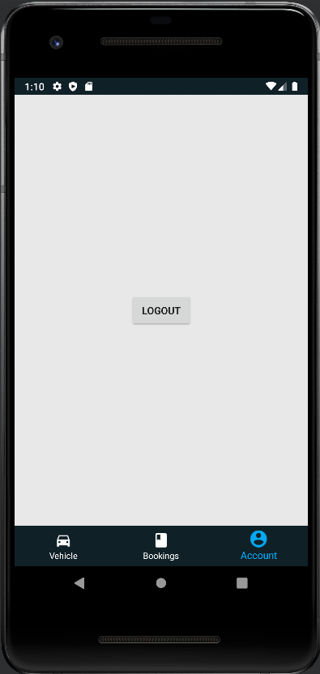

**APPENDIX F**

**Working Title Form**

Republic of the Philippines

**SOUTHERN LEYTE STATE UNIVERSITY**

Sogod, Southern Leyte

Website: [www.slsuonline.edu.ph](http://www.slsuonline.edu.ph)

Email: [slsumaincampus@gmail.com](mailto:slsumaincampus@gmail.com)

op@slsuonline.edu.ph Telefax No. (053) 382-3294

***College of Computer Studies and Information Technology***

**Proponents/Researchers:**

|  |
| --- |
| Jess Christian Retulla |
| Jobe Paran |
| Fred Matthew Espiel |
| Kenn Francis Villas |
|  |

**Proposed Project Title:**

|  |
| --- |
| **CarAvang: Post and Rent Cars**  **Mobile Application**  **System** |

|  |  |
| --- | --- |
| **Submitted by:**  **Jess Christian C. Retulla**  (Signature of Project Manager over printed name)  Date: | **Noted:**  **Dr. Rhoderick Malangsa**  (Signature of Adviser over printed name)  Date: |
| **Recommending Approval:**  (Signature of Patent Searcher over printed name)  Date: | **Approved:**  **Alex C. Bacalla, DIT**  (Signature of Dean over printed name)  Date: |

**APPENDIX G**

**Grammarians’ Certification**

Republic of the Philippines

**SOUTHERN LEYTE STATE UNIVERSITY**

Sogod, Southern Leyte

Website: [www.slsuonline.edu.ph](http://www.slsuonline.edu.ph)

Email: [slsumaincampus@gmail.com](mailto:slsumaincampus@gmail.com), [op@slsuonline.edu.ph](mailto:op@slsuonline.edu.ph)

Telefax No. (053) 382-3294

***College of Computer Studies and Information Technology***

Date: _____________

**G R A M M A R I A N ‘ S C E R T I F I C A T E**

This is to certify that the undersigned has reviewed and went through all the pages of the proposal project study / research entitled “CarAvang”: Post and Rent Cars Mobile Application System” as against the set of structural rules that governs the composition of sentences, phrases, and words in the English language.

Signed:

_________________________

Grammarian

Conformed:

**Jess Christian C. Retulla**

Project Manager

**APPENDIX H**

**Curriculum Vitae**

**Full name: Jess Christian Retulla**

Address: Pontod, Hilongos, Leyte

Mobile Number: 09457363831

Email Address: jesschristianretulla0@gmail.com

**PERSONAL INFORMATION**

Nickname : chan

Date of Birth : January 08, 1998

Place of Birth : Hilongos, Leyte

Civil Status : Single

Citizenship : Filipino

Age : 24

Gender : Male

Religion : Roman Catholic

Father's Name : Jericho Retulla

Mother's Name : Florabel Retulla

**EDUCATIONAL ATTAINMENT**

Tertiary Education : Southern Leyte State University

Year : 2021-2022

Course : BS Information Technology

Major : Programming

Address : Sogod, Southern Leyte

Secondary Education : Hilongos National Vocational School

Year : 2019

Strand : STEM

Specialization : STEM

Address : Hilongos, Leyte

**Full name: Kenn Francis B. Villas**

Address: Poblacion 2 Hindang Leyte

Mobile Number: 09073302760

Email Address: kennvillas27@gmail.com

**PERSONAL INFORMATION**

Nickname : kenn

Date of Birth : July 27, 1999

Place of Birth : Hindang, Leyte

Civil Status : Single

Citizenship : Filipino

Age : 22

Gender : Male

Religion : Catholic

Father's Name : Francisco S. Villas

Mother's Name : Irenea B. Villas

**EDUCATIONAL ATTAINMENT**

Tertiary Education : Southern Leyte State University

Year : 2021-2022

Course : BS Information Technology

Major : Programming

Address : Sogod, Southern Leyte

Secondary Education : Hilongos National Vocational School

Year : 2019

Strand : Techvoc

Specialization : SMAW

Address : Hilongos, Leyte

**Full name: Jobe R. Paran**

Address: Talisay, Hilongos, Leyte

Mobile Number: 09760184381

Email Address: jobeparan@gmail.com

**PERSONAL INFORMATION**

Nickname : Job

Date of Birth : January 12, 1999

Place of Birth : Hilongos, Leyte

Civil Status : Single

Citizenship : Filipino

Age : 23

Gender : Male

Religion : Roman Catholic

Father's Name : Cecilio Paran

Mother's Name : Avelina Paran

**EDUCATIONAL ATTAINMENT**

Tertiary Education : Southern Leyte State University

Year : 2021-2022

Course : BS Information Technology

Major : Programming

Address : Sogod, Southern Leyte

Secondary Education : Hilongos National Vocational School

Year : 2019

Strand : STEM

Specialization : STEM

Address : Hilongos, Leyte

**Full name: Fred Matthew Espiel**

Address: Maasin City, Southern Leyte

Mobile Number: 09746372831

Email Address: fred@gmail.com

**PERSONAL INFORMATION**

Nickname : matts

Date of Birth : September 29, 1999

Place of Birth : Sta Cruz, Maasin City, Southern Leyte

Civil Status : Single

Citizenship : Filipino

Age : 23

Gender : Male

Religion : Roman Catholic

Father's Name : Fredo Espiel

Mother's Name : Maria Espiel

**EDUCATIONAL ATTAINMENT**

Tertiary Education : Southern Leyte State University

Year : 2021-2022

Course : BS Information Technology

Major : Programming

Address : Sogod, Southern Leyte

Secondary Education : San Rafael National High School

Year : 2019

Strand : STEM

Specialization : STEM

Address : San Rafael, Maasin City